**GitHub Help Onboarding: Created by Harrison Watycha**

Firstly, I found this comprehensive video posted by a tutor:

<https://deakin365.sharepoint.com/sites/DeakinSITCapstone/_layouts/15/stream.aspx?id=%2Fsites%2FDeakinSITCapstone%2FShared%20Documents%2F%F0%9F%90%B1%E2%80%8D%F0%9F%92%BBGitHub%20Workshop%20and%20Support%2FRecordings%2FGitHub%20workshop%201%202024%20T2%2Emp4&nav=eyJyZWZlcnJhbEluZm8iOnsicmVmZXJyYWxBcHAiOiJTdHJlYW1XZWJBcHAiLCJyZWZlcnJhbFZpZXciOiJTaGFyZURpYWxvZy1MaW5rIiwicmVmZXJyYWxBcHBQbGF0Zm9ybSI6IldlYiIsInJlZmVycmFsTW9kZSI6InZpZXcifX0&ct=1731651947780&or=Teams%2DHL&ga=1&referrer=StreamWebApp%2EWeb&referrerScenario=AddressBarCopied%2Eview%2Ead13a50f%2D93a8%2D4ca9%2D96e7%2D3081b51018cc>

## **1. What is GitHub?**

GitHub is a platform for managing and sharing code. For this project, we’ll use GitHub to:

* Collaborate on the Deakin VR project.
* Track changes in the codebase.
* Share updates and improvements.



## **2. Setting Up GitHub (Desktop Application) (Option 1)**

Before you can start contributing, you’ll need to set up GitHub on your computer.

### **Step 1: Create a GitHub Account (You should have one from previous unit, but if not utilise below)**

1. Go to [github.com](https://github.com/) and sign up for a free account.
2. Verify your email address to activate your account.

### **Step 2: Install GitHub Desktop**

We’ll use GitHub Desktop, a beginner-friendly app for managing your repositories.

#### **For macOS:**

1. Download GitHub Desktop for macOS from [desktop.github.com](https://desktop.github.com/).
2. Open the downloaded .dmg file and drag the GitHub Desktop app to your **Applications** folder.
3. Launch the app from your **Applications** folder.

#### **For Windows:**

1. Download GitHub Desktop for Windows from [desktop.github.com](https://desktop.github.com/).
2. Open the .exe file and follow the installation instructions.
3. Once installed, launch the GitHub Desktop app.

### **Step 3: Log into GitHub Desktop**

1. Open GitHub Desktop.
2. Click **Sign In to GitHub.com** and log in with your GitHub account credentials.

## **3. Joining the Deakin VR Repository**

### **Option 1: Forking the Repository (Recommended for Beginners)**

Forking creates a copy of the repository in your account so you can work on it without affecting the original.

1. Go to the **Deakin VR repository** on GitHub (a link will be provided to you).
2. Click the **Fork** button at the top-right corner.
3. A copy of the repository will appear in your GitHub account.

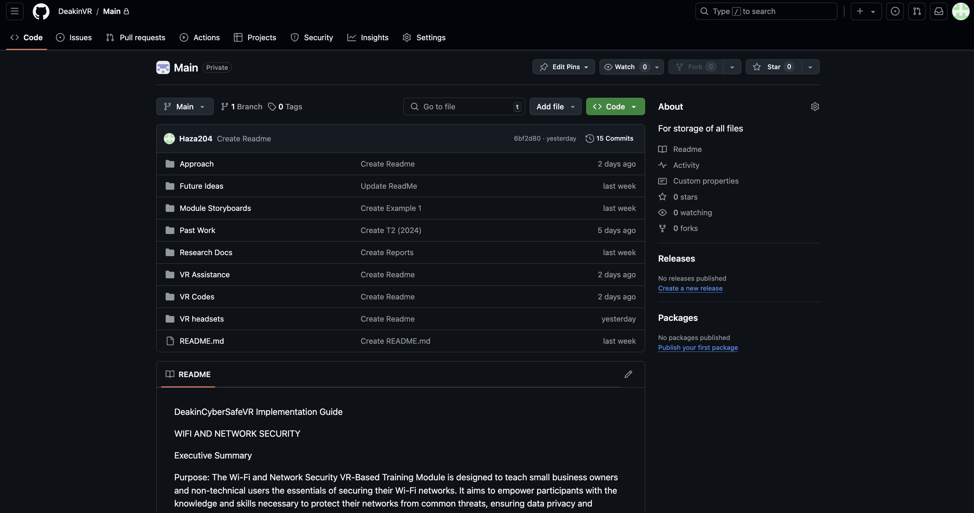

### **Option 2: Collaborator Access**

If you’ve been added as a collaborator:

1. Check your email for an invitation to join the repository.
2. Click **Accept** in the email or on the repository page.

## **4. Cloning the Repository to Your Computer**

Once you have access to the repository, you’ll want to work on it locally.

### **Using GitHub Desktop:**

1. Open GitHub Desktop.
2. Click **File > Clone Repository**.
3. In the dialog box:
   1. **If you forked the repository**: Select it from your list of repositories.
   2. **If you’re a collaborator**: Enter the repository URL (e.g., <https://github.com/DeakinVR/DeakinVR-Repo.git>).
4. Choose a folder on your computer to store the project.
5. Click **Clone** to download the repository.

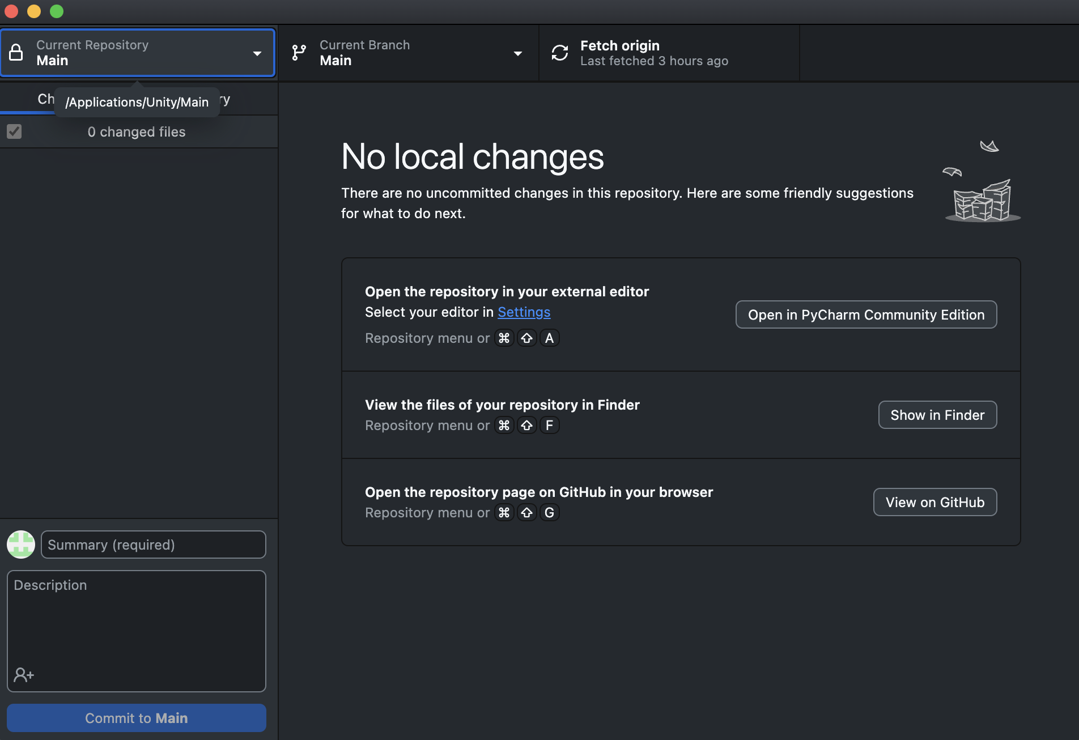

## **5. Making Changes and Committing**

GitHub tracks changes to the codebase. Here’s how to make updates:

1. **Edit Files**: Make changes to files in the repository folder on your computer.
2. **GitHub Desktop**:
   1. The app will automatically detect changes.
   2. Add a brief description of your changes in the **Summary** field (e.g., "Added VR feature").
   3. Click **Commit to main** to save your changes locally.

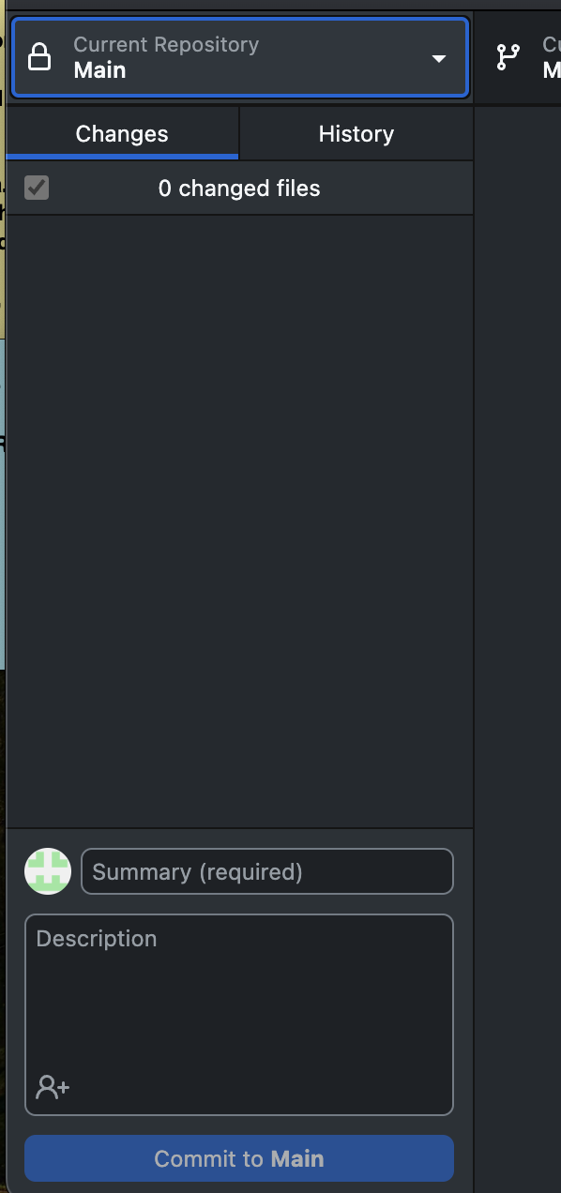

(Type a summary, and attach the file you are uploading)

## **6. Pushing Changes to GitHub**

1. Once you’ve committed changes, click **Push origin** in GitHub Desktop.
2. This uploads your changes to the repository on GitHub.



## **7. Syncing with the Main Repository**

To stay updated with changes made by others:

1. In GitHub Desktop, click **Fetch origin**.
2. If there are updates, GitHub Desktop will prompt you to pull the changes.

## **8. Collaborating with Pull Requests**

If you forked the repository, you’ll need to create a pull request to contribute your changes.

1. On the GitHub website, go to your forked repository.
2. Click **Pull Request** and choose the branch you want to merge into the main repository.
3. Add a title and description for your pull request and submit it.
4. The project maintainers will review and merge your changes.

## **GitHub setup (command line, website) (Option 2)**

### **Installing Git**

* **For macOS**:
  + Open Terminal.
  + Type:

“git --version”

**For Windows**:

1. **Download Git from** [**git-scm.com**](https://git-scm.com/) **and run the installer.**
2. **During installation:**
   1. **Choose "Use Git from Git Bash only" or "Git from the command line."**
   2. **Set up your preferred text editor (e.g., VS Code).**
3. **Open Git Bash from the Start menu and verify the installation:**

“git --version”

### **Configuring Git**

1. **Set your username and email (these must match your GitHub account):**

“git config --global user.name "YourGitHubUsername"”  
“git config --global user.email "[YourEmail@example.com](mailto:YourEmail@example.com)"”

1. **To verify your settings:**

“git config –list"

## **3. Joining the Deakin VR Repository**

### **Option 1: Forking the Repository**

Forking creates your own copy of the repository on GitHub:

1. Go to the **Deakin VR repository** (a link will be provided).
2. Click the **Fork** button in the top-right corner.
3. This creates a copy in your GitHub account.



### **Option 2: Collaborator Access**

If you’ve been added as a collaborator:

1. Check your email for an invitation to join the repository.
2. Accept the invitation and ensure the repository is listed in your account.

## **4. Cloning the Repository**

Once you have access to the repository:

1. Open a terminal (or Git Bash on Windows).
2. Clone the repository to your local computer:

git clone <https://github.com/your-username/DeakinVR.git>

1. Navigate to the project folder:

cd DeakinVR (Just for an example)

## **5. Making Changes**

### **Step 1: Create a Branch**

Always create a new branch for your work to keep the main branch clean:

“git checkout -b feature-branch-name"

### **Step 2: Make Changes**

Edit the project files on your computer using any text editor (e.g., VS Code or even PyCharm).

### **Step 3: Stage and Commit Changes**

1. **Stage changes**:

“ git add “

1. **Commit changes** with a message describing what you’ve done:

git commit -m "Added new VR feature"

## **6. Pushing Changes to GitHub**

1. **Push your branch to GitHub:**

“git push origin feature-branch-name"

1. **Your changes will now appear in your forked repository (or directly in the main repository if you’re a collaborator).**

## **7. Syncing with the Main Repository**

If you forked the repository, you’ll need to keep it updated with changes from the main repository:

1. **Add the main repository as an upstream remote:**

git remote add upstream <https://github.com/DeakinVR/DeakinVR.git>

1. **Fetch updates from the main repository:**

“git fetch upstream”

1. **Merge updates into your local branch:**

“git merge upstream/main”

## **8. Contributing via Pull Requests**

1. Push your branch to your forked repository (see step 6).
2. On the GitHub website, go to your forked repository.
3. Click **Pull Request** and choose the branch you want to merge into the main repository.
4. Add a title and description for your pull request and submit it.
5. The project maintainers will review and merge your changes.